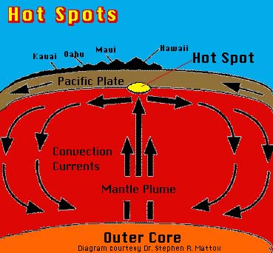
Hot Spots
1) Describe the picture to the left.

2) Explain what creates a hot spot and what these constructive forces do to the oceanic and continental crusts. Make sure to use vocabulary words such as mantle, lithosphere, and increased density.

3) Why are most hot spots located at mid-ocean ridges? Make sure to use the word divergent boundaries to answer the question.

4) Describe in as much detail as you can on how a hot spot has made the Hawaiian Islands.

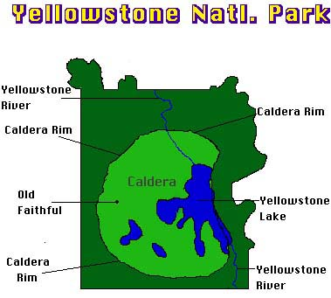
5) What tectonic plate action has created Yellowstone National Park? Make sure to use the words: caldera, North American Plate and hot spot in your answer.

