Ring of Fire Notes….

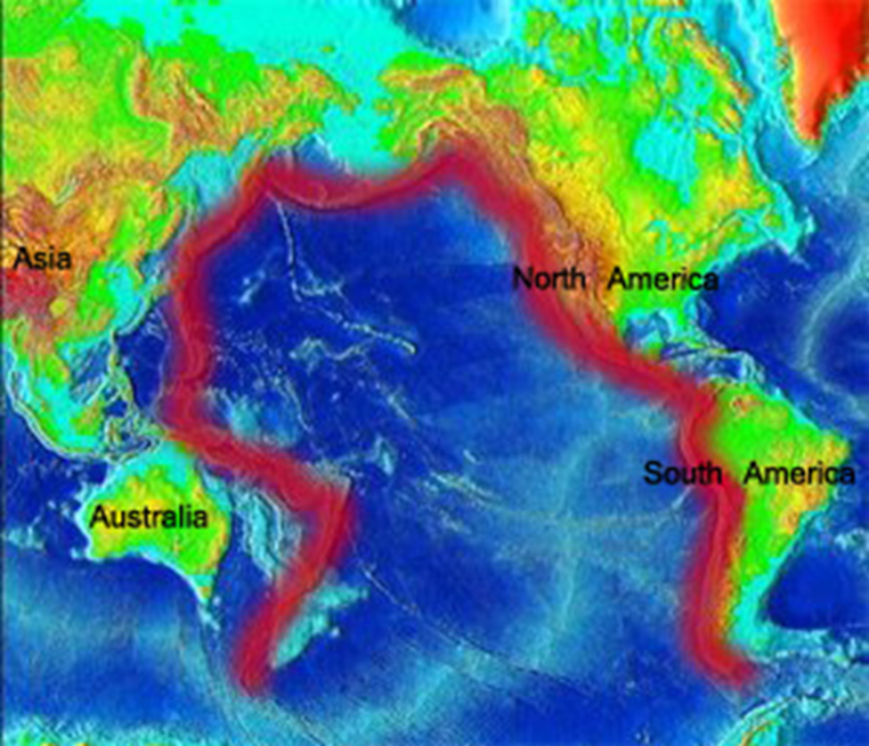

Where can you find hot spots in the lithosphere?

A hot spot is……



Hot Spot Notes

The RING OF FIRE is…….

What shape is the ring of fire and where is it located?

How many volcanoes are there and what percent of the world’s earthquakes happen in the ring of fire?