What is an Index Fossil?

Introduction

One of the most economically valuable uses of fossils is for finding oil. Oil companies are interested in the age of rocks because oil was produced during certain time periods on Earth. One of the most prolific periods of oil production was during the Cretaceous. During this time, marine algae died and built up in great quantities on the seafloor. When this organic material is buried, it is heated and put under pressure. If this continues to the right temperature and pressure, then oil is produced. The Persian Gulf region is rich in oil because it contains large quantities of rock from this time period.

Dating a rock using fossils is called relative dating. This is because the rocks are dated relative to each other. For instance, if one rock has a fossil T. rex and another has a fossil Saber Tooth Tiger, the one with the Saber Tooth Tiger is younger because we know that dinosaurs went extinct before large mammals appeared on earth. However, without more advanced technology, namely radioactive dating, we can’t figure out exactly how old the T. Rex or the Saber Tooth Tiger are.

Ammonites are organisms that lived in the oceans at the same time as the dinosaurs roamed on Earth. They also went extinct with the extinction of the dinosaurs, at the end of the Cretaceous Period. They were very abundant, evolved rapidly, and are easily identifiable. Therefore, they are very useful to geologists who try to identify the age of rock units.

In this activity, you will create a fossil range chart for ammonites and their relatives in the Class Cephalapoda, which includes modern species such as octopuses, squids, cuttlefish, and nautilus. You will then use the information in the chart to determine the age of particular rocks and to predict which rock might contain oil.

Procedure
Make a fossil range chart (a chart like the one we saw with the teachers’ names on it). Look at the pictures of fossils in figure 1. Each fossil represents an order that contains a variety of genera and species. Underneath each picture is a time range. Shade in the area on your worksheet that represents the time period during which the fossil existed. For instance, for the Goniatites, shade in everything from the Carboniferous to the Permian (including the Carboniferous and the Permian). When this is complete, you will have made a fossil range chart.

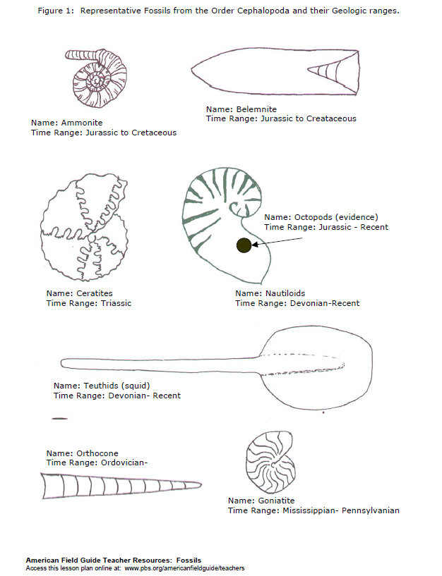

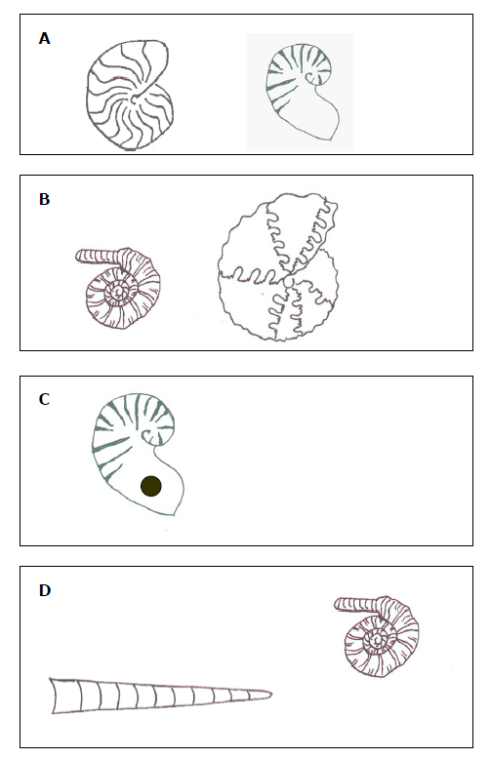

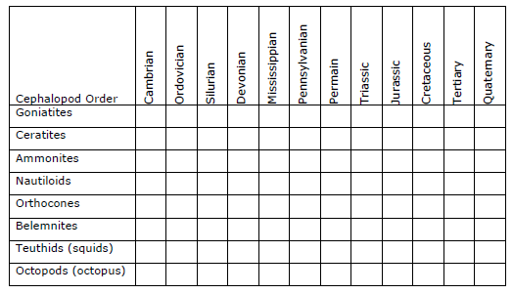

Data Analysis
- If you have a rock that has a Ceratite in it what time period(s) is it from? How do you know?

- If you have a rock that has a Goniatite and a Nautiloid what time period(s) is it from? How do you know?

- If you have a rock that has an Ammonite and an Orthocone in it, what time period(s) is it from? How do you know?

- If you find a rock that has an Orthocone what time period(s) is it from? How do you know? How is this fossil evidence different from the fossils in questions 1, 2, and 3?

- If you find a sedimentary rock that has no Belemnites in it, can you tell what time period it is from (using the information available in this lab only)? Why or why not?

- An “index fossil” is a fossil that makes it easy for you to figure out what time period a rock is from. Which fossil(s) make the best index fossils?

Application

- Look at the following diagrams of fossils that can be found in rocks. Identify the fossils using the pictures in figure 1. Then determine the age of each rock.

- Cephalopods are organisms that lived in the open ocean. During the Cretaceous, a lack of oxygen in ocean basins meant that large deposits of organic material built up. This material came primarily from microorganisms in the ocean water. This material was later buried and eventually became oil. Geologists from oil companies frequently use range charts to help them date rocks so that they might find more oil.

- Imagine that you are an oil geologist. Of the rocks you dated in question 8, which would you recommend further investigation for oil?

Data Analysis
- If you have a rock that has a Ceratite in it what time period(s) is it from? How do you know?

- If you have a rock that has a Goniatite and a Nautiloid what time period(s) is it from? How do you know?

- If you have a rock that has an Ammonite and an Orthocone in it, what time period(s) is it from? How do you know?

- If you find a rock that has an Orthocone what time period(s) is it from? How do you know? How is this fossil evidence different from the fossils in questions 1, 2, and 3?

- If you find a sedimentary rock that has no Belemnites in it, can you tell what time period it is from (using the information available in this lab only)? Why or why not?

- An “index fossil” is a fossil that makes it easy for you to figure out what time period a rock is from. Which fossil(s) make the best index fossils?

Application

- Look at the following diagrams of fossils that can be found in rocks. Identify the fossils using the pictures in figure 1. Then determine the age of each rock.

- Cephalopods are organisms that lived in the open ocean. During the Cretaceous, a lack of oxygen in ocean basins meant that large deposits of organic material built up. This material came primarily from microorganisms in the ocean water. This material was later buried and eventually became oil. Geologists from oil companies frequently use range charts to help them date rocks so that they might find more oil.

- Imagine that you are an oil geologist. Of the rocks you dated in question 8, which would you recommend further investigation for oil?

